**Assignment on Linux Masterclass**

# Create a file via touch and update that file and also verify the timestamp and output will be redirected to another file.

**Step 1:** Create a new directory using “mkdir”.

**Step 2:** Go to that directory using “cd” command.

**Step 3:** Use touch command to create a file. Check whether the file created or not using “ls” command.

**Step 4:** Check the timestamp using “ls -l” command.

**Step 5:** To open the file and write “vim” command.

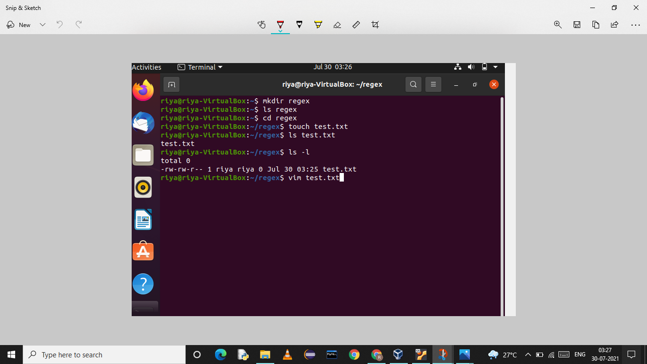

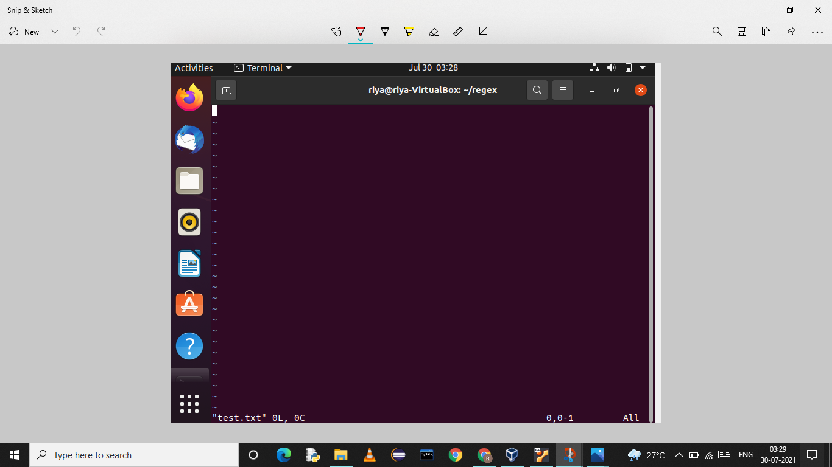

**Step 6: To write in this file press on ‘I’ key to insert.**

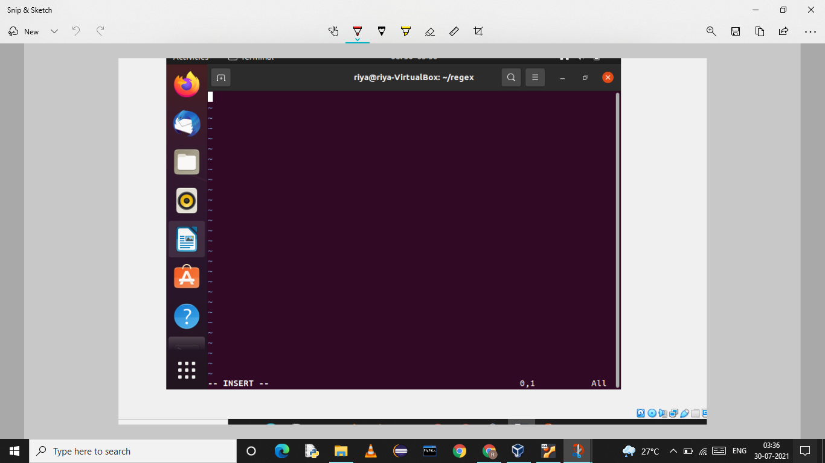

**Step 7: To get back from insert mode press escape key and select shift colon and type “wq” .**

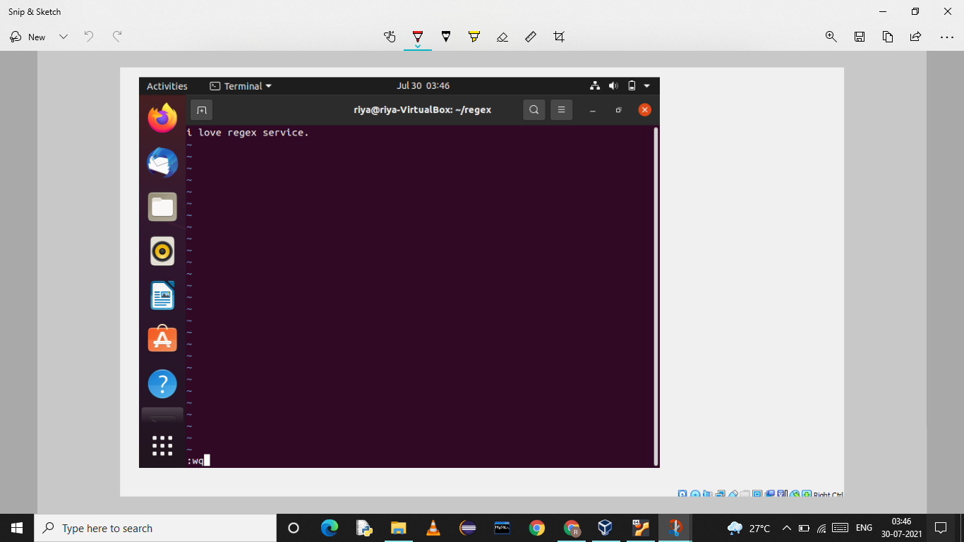

**Step 8:** To check the content of file use “cat” command.

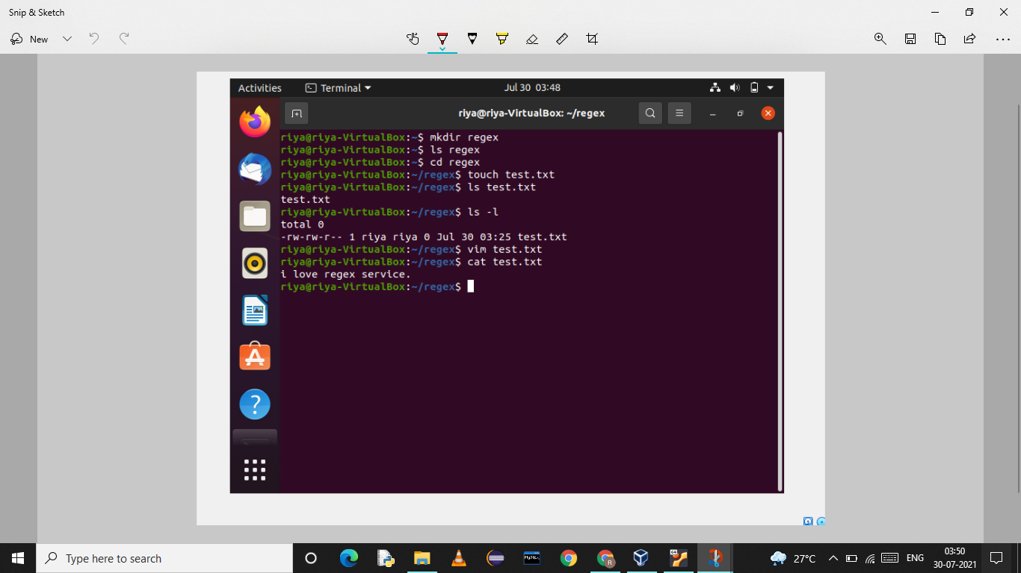

# Q.2:Add some of the data as per your choice and append that data via echo command in the same file.

# => Use “echo” command to write something without opening the file.

# 

**Q.3:Install httpd and set up your own web server.**

**=> Step1**: Install using command sudo apt install apache2.

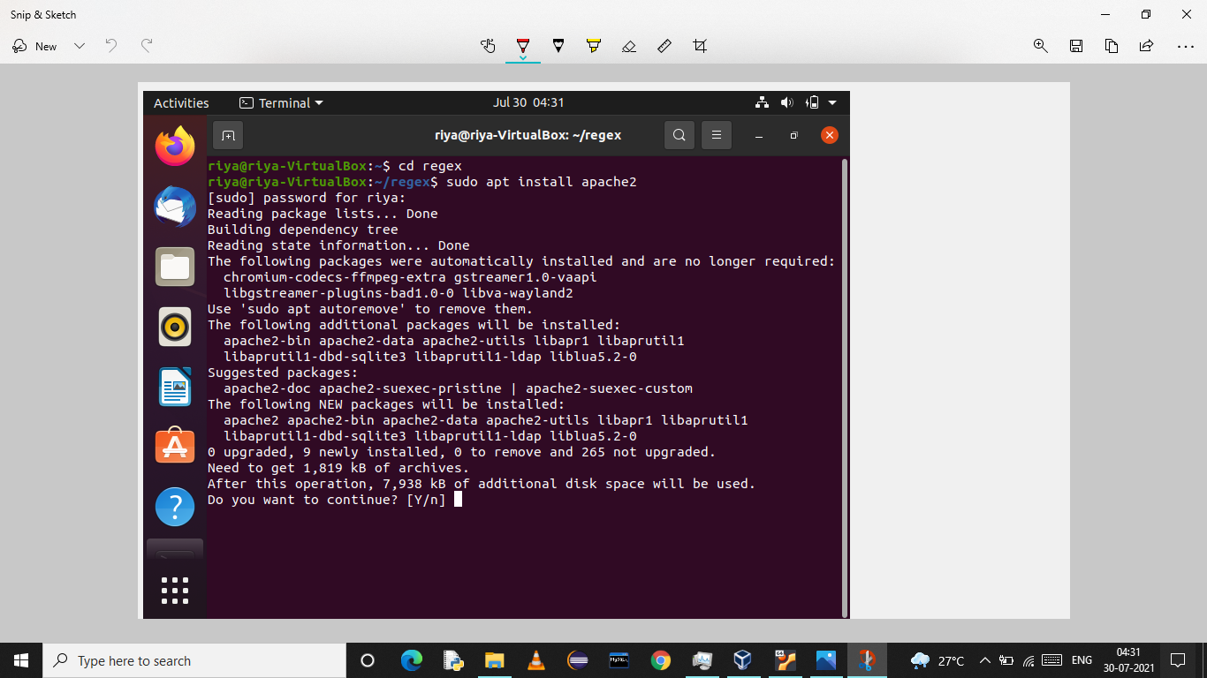

**Step 2:** To start httpd use command “systemctl start httpd”.

**Step 3**: To enable httpd use command “systemctl enable httpd”.

**Step 4:** To check the status of httpd use command “systemctl status httpd”.

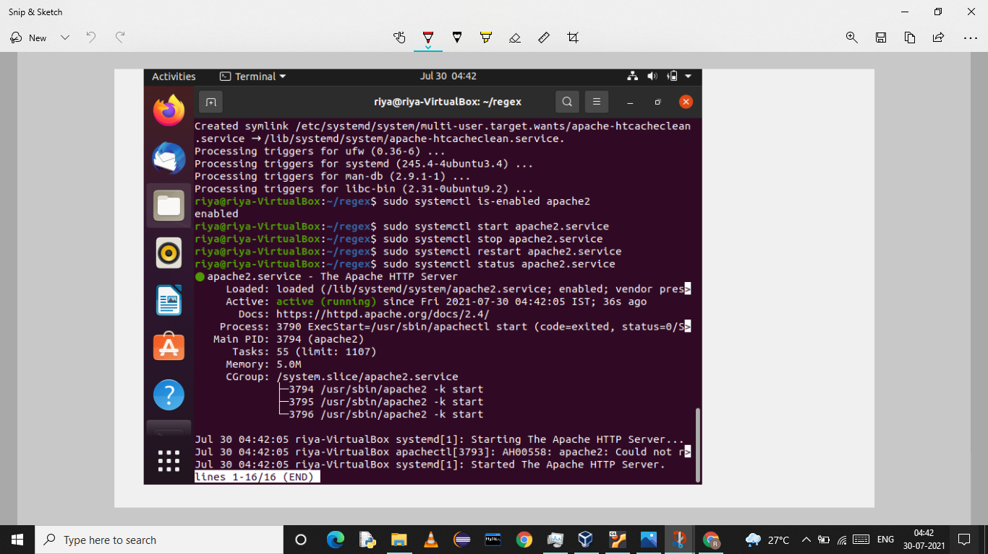

# Q.4:Create another VM and setup password less authentication.

**Step 1:** Go to Oracle VM VirtualBox and right click on the current Ubuntu and select clone.

# 

**Step 2:** keep the settings as it is and just click Next.

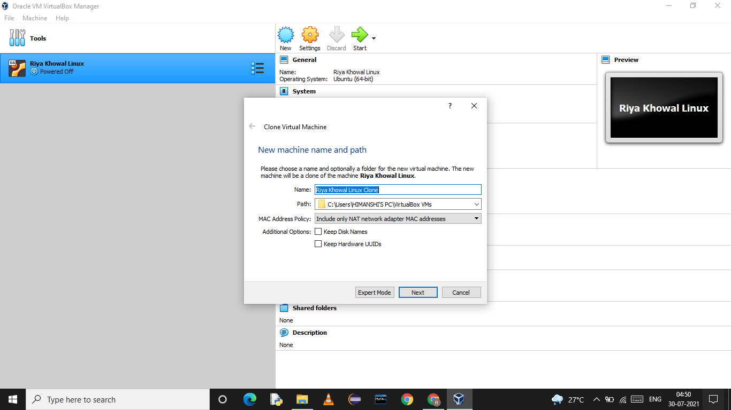

**Step 4:**selectfull clone andClick Clone. This will set another Ubuntu in your VirtualBox.

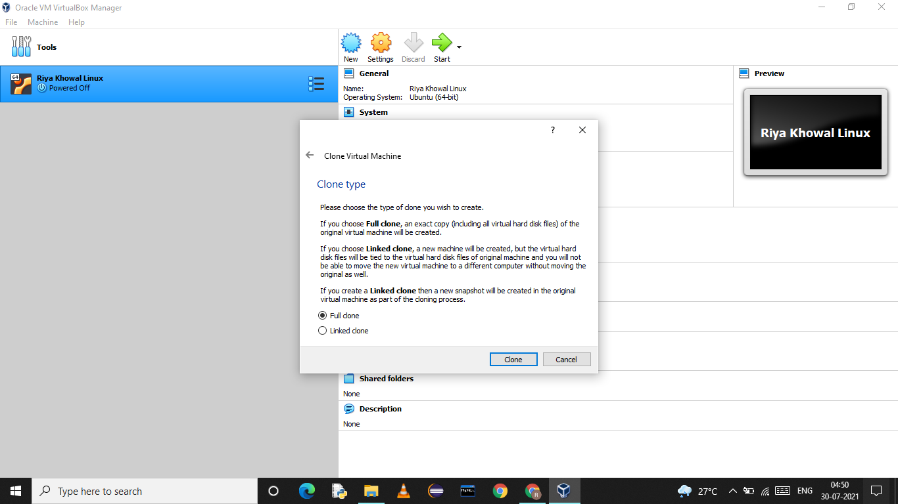

**Setup PASSWORD — LESS AUTHENTICATION.**

**Step 1:** Generate the key using “ssh-keygen” in host1 and enter authentication credentials.

**Step 2:** Then copy this key in host2 using command “ssh-copy-id root@(ip address of host2)”. host2 will verify if it’s coming from the right source or not and if the key is matched, it means you are able to login. After that you need not to enter password while accessing host2 anymore.

This is less authentication Password setup to access different host.

